# **A picture containing text, graphics, graphic design, poster Description automatically generatedA logo of a balloon Description automatically generated with low confidenceHoopla!**

**Volunteer Brief**

Cloud Cuckoo Land Theatre is looking for volunteers to help us to deliver a programme of outdoor music and theatre workshops during Summer 2023 for a group of children from newly-arrived refugee and migrant families living in Birmingham.

**Volunteer roles and responsibilities:**

* Supporting project participants to attend workshop sessions, greeting and welcoming families and children; assisting with co-ordination of transport to and from the workshop venue.
* Assisting in preparation of drinks and snacks for participants at workshop venue.
* Supporting delivery of a community refugees welcome event on 15th August at Selwyn Road Playing Field.

We will mainly be working with families who are currently living at the Collection Hotel, Hagley Road and Britannia Hotel, New Street. We need volunteers to meet the families who have signed up to participate in the project, at an agreed location within or close to the hotel where they are living, on the dates of the workshops, and assist them in getting into pre-booked taxis that will take them to the workshop location.

Ideally we would like to work with volunteers who can do the majority of the project dates so that you become a known face that participants recognise each week.

We might also invite you to a project briefing with participants at the hotels before the project begins.

**Sign up as a volunteer:** Email [ccl@curiosityproductions.co.uk](mailto:ccl@curiosityproductions.co.uk) with your availability on the dates listed below by 20th July. For more information call/ text/ WhatsApp 07376 020819

**Project dates and venue**

Workshop venue: Selwyn Road Playing Fields (Red Shed), B16 0SL (carpark off Selwyn Road or pedestrian access from Edgbaston Reservoir)

Meeting points for participants: Collection Hotel, Hagley Road and Britannia Hotel, New Street.

Dates: Saturday 22nd July, 12pm – 4.30pm (workshop 1.30pm – 3.30pm)

Wednesday 26th July, 12pm – 4.30pm (workshop 1.30pm – 3.30pm)

Tuesday 1st August, 12pm – 4.30pm (workshop 1.30pm – 3.30pm)

Tuesday 8th August, 12pm – 4.30pm (workshop 1.30pm – 3.30pm)

Tuesday 15th August, exact times tbc (approx. 10am – 6pm) – part of a wider community refugees welcome event.

**About the project**

**Hoopla!** will be an interdisciplinary, child-led creative play space for children aged 2-12, introducing them to natural landscapes near where they live. It aims to create a gentle creative haven where children with unstable living / schooling situations are made welcome, listened to, and offered much-needed space to express themselves through responsive music, drama & arts activities. The project will be supported by a paid trainee artist facilitator with lived experience of forced migration.

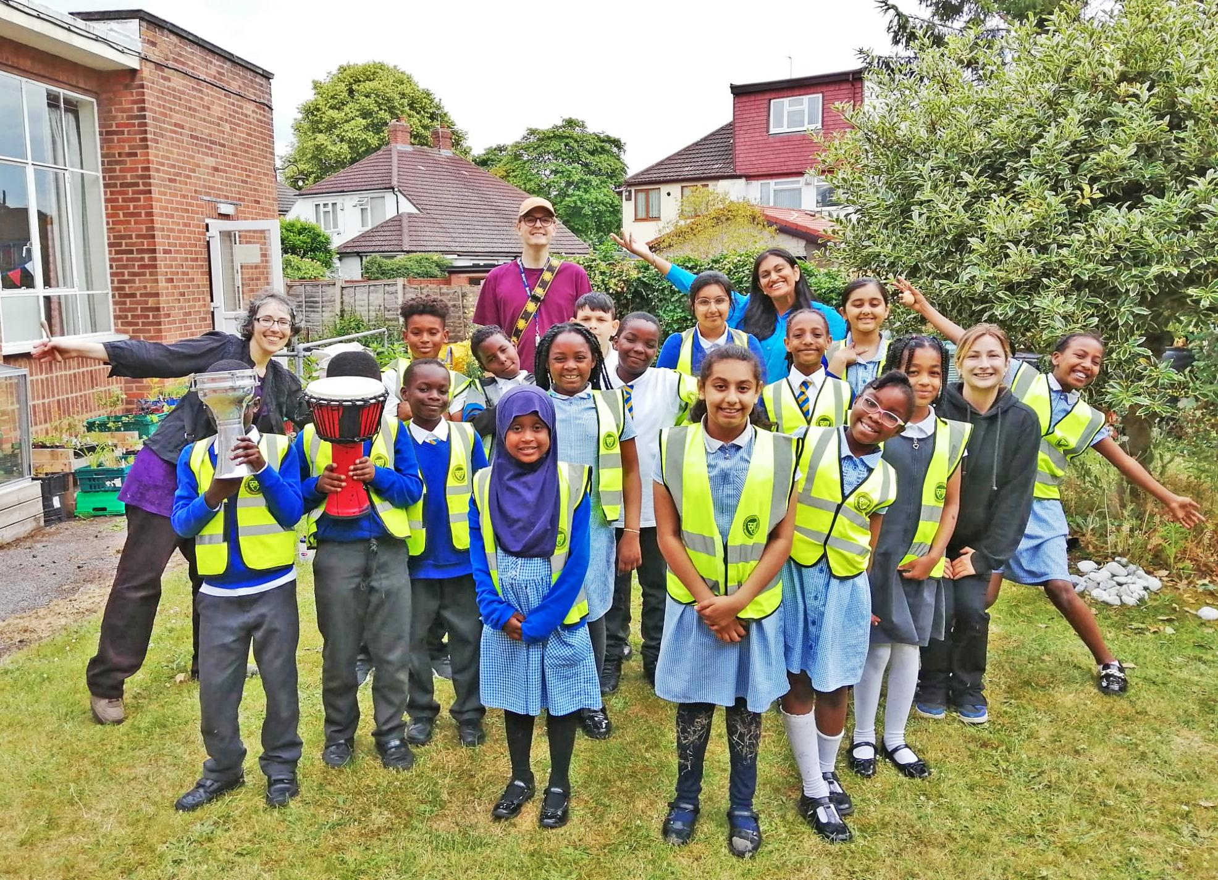*Cloud Cuckoo Land’s facilitators working with recently arrived children in Hodge Hill*

This project is funded by Birmingham City Council and supported by Birmingham Settlement, Birch Network and Kings Heath Action for Refugees.

**Hoopla!** develops CCL's experience working with young refugees, supporting their specific needs via high artist-child ratios, non-verbal facilitation, engaging them with natural green space on their doorstep, supporting their nutrition, and sensitive family engagement support. The project will grow and celebrate the voices of Birmingham's least heard children. The process will culminate in a final session that sees the participants invite others into the creative space they've inhabited and co-created, as they lead their own programme of participatory creative play activities. We hope that this final session will be part of a wider community day with a Refugees Welcome theme, inviting a range of local groups to take part and share what they have to offer with the participants and the wider community. 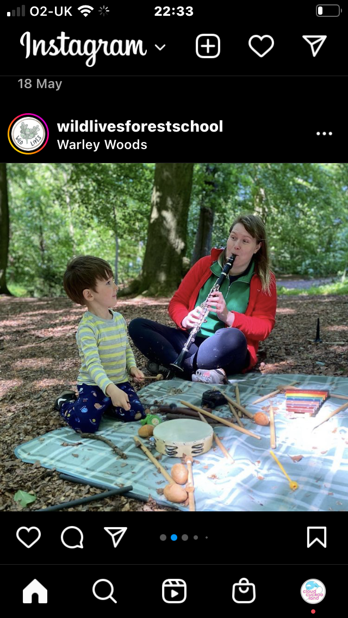

## **About Cloud Cuckoo Land Theatre**

We’re a neuro-divergent led organisation with our head in the clouds and our feet firmly planted in Brummie soil. We make, support and promote creatively inventive participatory music theatre and multi-artform activities. Our work has a dedicated focus towards young people in systemically marginalised communities, and is normally developed in collaboration with grassroots local partners. We work with [Curiosity Productions](https://curiosityproductions.co.uk/) to manage our projects. We create transformative imaginative spaces where everyone is welcome, listened to and cared for. We support children in systemically marginalised communities by asking them to play an active creative role in participatory theatre/arts events which reflect their lives in playful, surprising ways. Our vision is a world where every young person can access outstanding multi-artform theatrical encounters which celebrate their creativity, in the heart of their local community. A picture containing text, font, graphics, graphic design
[**www.cloudcuckoolandtheatre.com**](http://www.cloudcuckoolandtheatre.com/)